

**FOOD NETWORK WEBSITE**



**TEAM MEMBER**

HAMEED-UR-REHMAN AFAQ AHMED

**PROJECT OVERVIEW**

1. **PLANNING PHASE**

**Purpose of the Restaurant Website:**

The goal of the website for our restaurant is to improve the overall customer experience by offering a variety of functionalities. Its main goal is to give customers an easy way to communicate with our restaurant on the internet. This include letting clients make bookings for tables online, letting them place orders via the internet, and providing a thorough look of our staff's information and menu. By adding these functions, the website becomes an online representation of our restaurant, improving accessibility and consumer interaction for both past and present customers.

**Target Audience:**

The people looking for online dining options and services are your target audience for the restaurant website. This includes local clients who want an easy way to order and make reservations, as well as those who want to check over the menu and find out more about the people who work at our restaurant. Customers that enjoy the convenience of online interactions and are tech-savvy are catered to by the website. Furthermore, it is an invaluable tool for prospective guests—both locals and tourists—who are looking for a restaurant that suits their tastes. Our restaurant website seeks to draw and keep consumers by providing them with easy-to-use and educational online experiences by comprehending and catering to the needs of this diverse audience.

**FIGMA:**

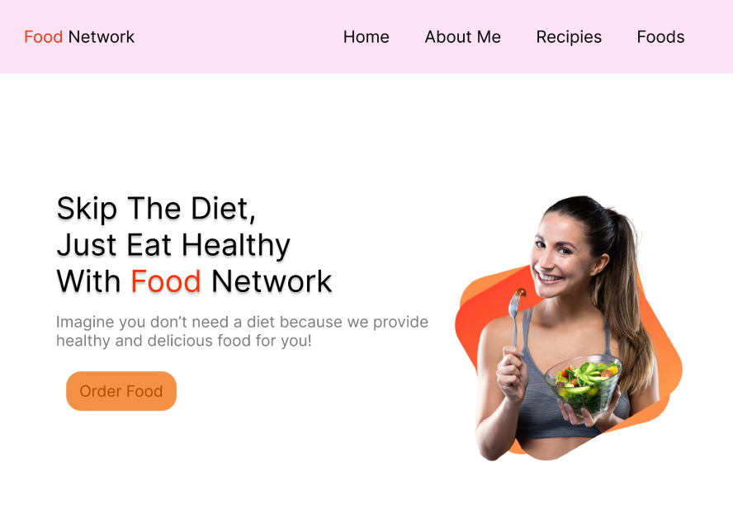

**HOME PAGE**

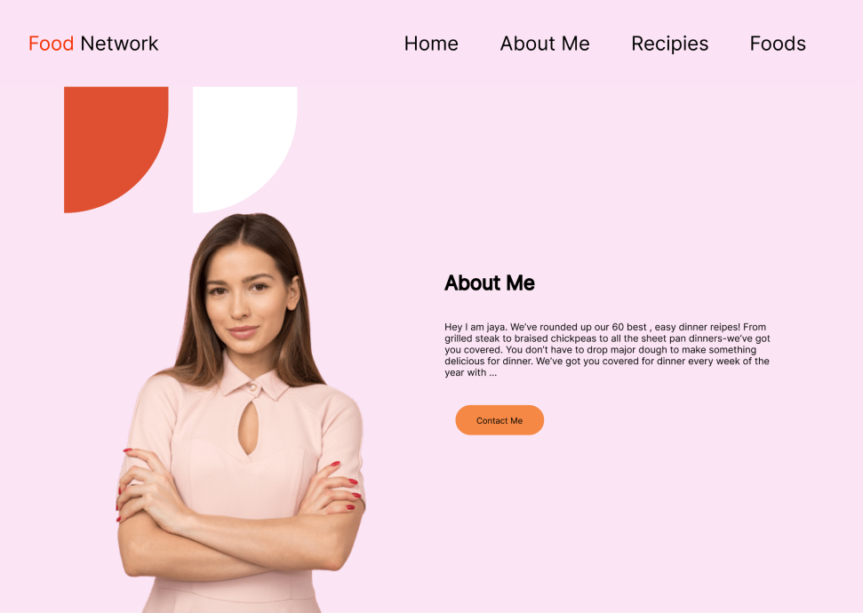

**ABOUT SECTION**

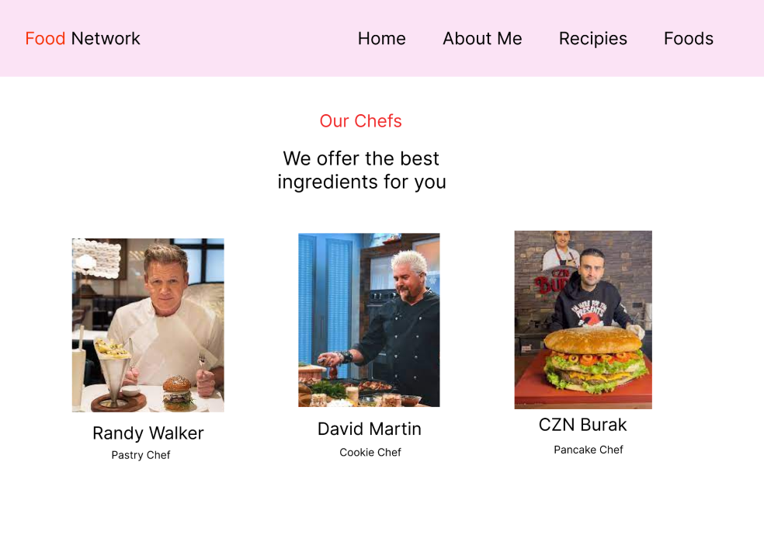

**STAFF SECTION**

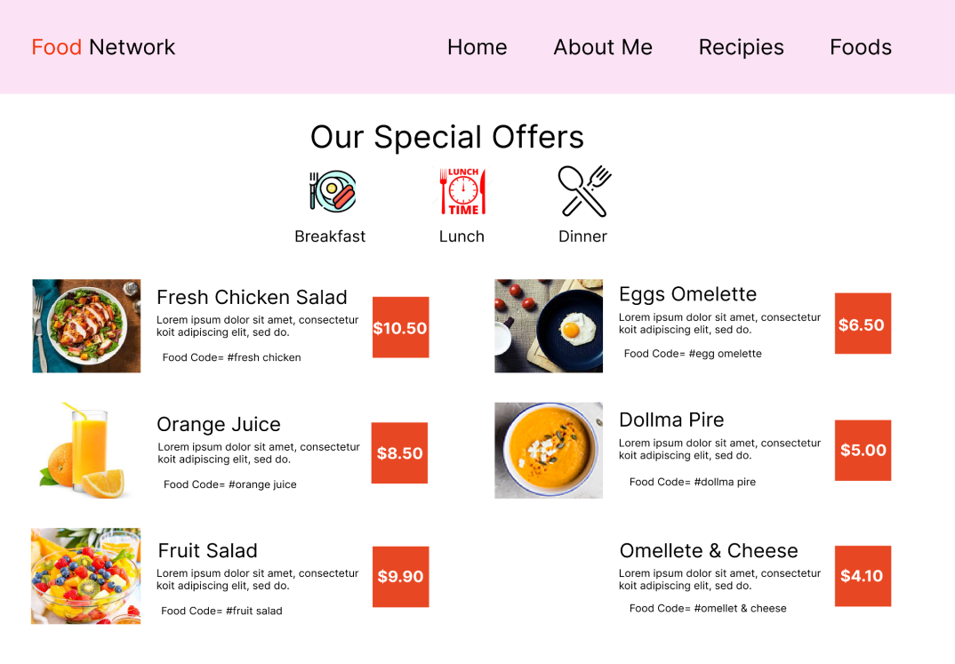

**MENU SECTION**

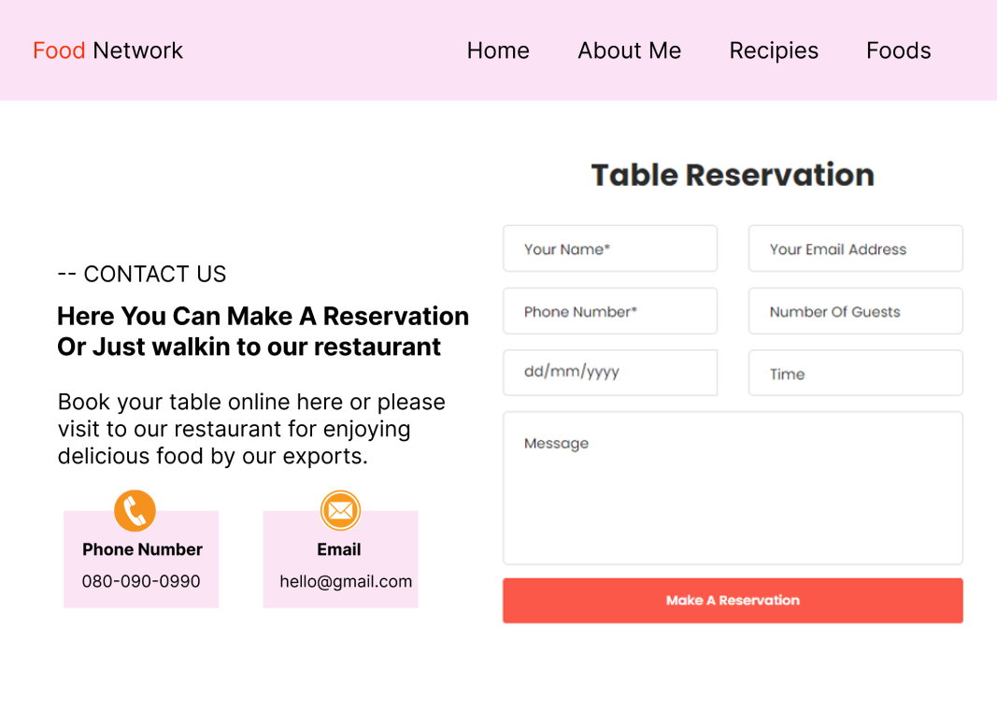

**TABLE RESERVATION SECTION**